Eulogy - continued  Can continue the eulogy on this page or put pictures here.  John/Jane Doe was born on January 1, 1950 at the mouth of the Peel to John and Jane (Smith) Doe. He/She was the 5th child of 10 children. Can add brothers and sister’s names if you wish too.  (At the end-thank you paragraph) Spouse, Child, child (list them all) and the family would like to express their appreciation for all the support the community has provided to them. The prayers, financial donations, visits, and food was greatly appreciated.  Ke’gwaadthat Nahkwah Vili’ (God Bless you all) |  |  | John/Jane Doe  Deceased Photo here (right click on photo and select change picture. Delete this text box once done.  January 1, 1950 - January 1, 2021
7
Celebration of Life for John/Jane Doe  January 1, 2021 – 3:00 PM  St. Matthew’s Church, Teetl’it Zheh, NT (Fort McPherson)  Order of Service  Officiant’s: Rev. Rebecca Blake  Lay Leader’s: Joanne Snowshoe & Arlyn Charlie  Opening Sentences: Page 589 Clergy  Psalm 121 (example): John/Jane Doe (name of Reader goes here)  I lift up my eyes to the hills; from where is my help to come?  My help comes from the Lord, the maker of heaven and earth.  He will not let your foot be moved and  he who watches over you will not fall asleep.  Behold, he who keeps watch over Israel  shall neither slumber nor sleep;  The Lord himself watches over you;  the Lord is your shade at your right hand,  So that the sun shall not strike you by day, nor the moon by night.  The Lord shall preserve you from all evil;  it is he who shall keep you safe.  The Lord shall watch over your going out and your coming in,  from this time forth for evermore.  This is the word of the Lord  Thanks be to God  Opening Prayers: Page 591 Clergy |  |  | Eulogy: John/Jane Doe (Person reading)
John/Jane Doe was born on January 1, 1950 at the mouth of the Peel to John and Jane (Smith) Doe. He/She was the 5th child of 10 children. Can add brothers and sister’s names if you wish too.

You can talk about where they went to school, who they were married to, number of children, grandchildren, etc.

1 |  |  | 6

Pre-deceased By:  Spouse: Jane/John Doe  Children: John (Jane) Doe Jane (John) Doe Jane (John) Doe  John (Jane) Doe John Doe Jane Doe Jane Doe Jane Doe  Grandchildren: John (Jane) Doe Jane (John) Doe Jane (John) Doe  John (Jane) Doe John Doe Jane Doe Jane Doe Jane Doe  Mother/Father: John/Jane Doe  Grandmother/Grandfather: Jane/John Doe  Siblings: John (Jane) Doe Jane (John) Doe Jane (John) Doe  John (Jane) Doe John Doe Jane Doe Jane Doe Jane Doe  Brother & Sister In-laws: John Doe John Doe Jane Doe  Nieces/Nephews: John Doe Jane Doe  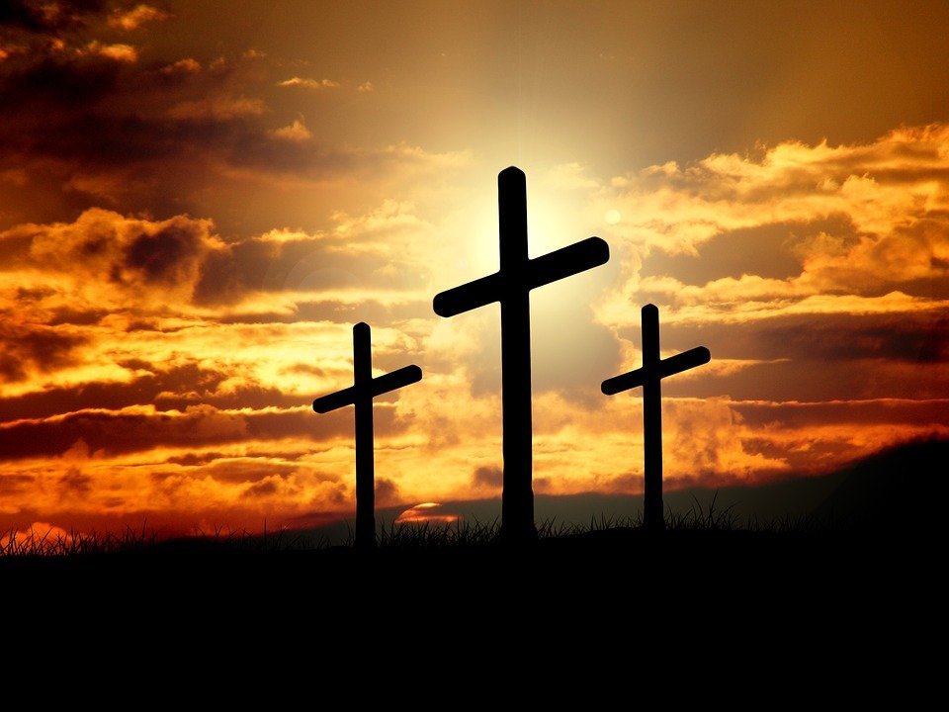 |  |  | Order of Service - continued
1st Reading: 1 John 3: 1-2 John/Jane Doe

¹Look at the remarkable love the father has given us – that we should be called God’s children! That indeed is what we are. That’s why the world doesn’t know us, because it didn’t know him.
² Beloved ones, we are now, already, God’s children; it hasn’t yet been revealed what we are going to be. We know that when he is revealed we shall be like him, because we shall see him as he is.

This is the word of the Lord
Thanks be to God

2nd Reading: 1 Isaiah 61: 1-3 John/Jane Doe

¹The Spirit of the Lord GOD is upon me; because the LORD hath anointed me to preach good tidings unto the meek; he hath sent me to bind up the broken-hearted, to proclaim liberty to the captives, and the opening of the prison to them that are bound;
²To proclaim the acceptable year of the LORD, and the day of vengeance of our God; to comfort all that mourn;
³To appoint unto them that mourn in Zion, to give unto them beauty for ashes, the oil of joy for mourning, the garment of praise for the spirit of heaviness; that they might be called trees of righteousness, the planting of the LORD, that he might be glorified.

This is the word of the Lord
Thanks be to God

Gospel: Lay Leader, Joanne Snowshoe
 |  |  | 2
5

Order of Service - continued  Apostles Creed:  I believe in God, the Father Almighty,  maker of heaven and earth;  And in Jesus Christ his only Son, our Lord;  who was conceived by the Holy Spirit,  born of the Virgin Mary,  suffered under Pontius Pilate,  was crucified, dead, and buried;  the third day he rose from the dead;  he ascended into heaven,  and sitteth at the right hand of God the Father Almighty;  from thence he shall come to judge the quick and the dead.  I believe in the Holy Spirit,  the holy catholic** church,  the communion of saints,  the forgiveness of sins,  the resurrection of the body,  and the life everlasting. Amen.  Special Song: Name of Song & Singer (or recorded song)  Eulogy: John/Jane Doe  Sermon: Rev. Rebecca Blake  Prayers for the People: Clergy  At the Committal: Clergy |  |  | John/Jane Doe  “A loving caring husband/wife/spouse. son/daughter/child, Grandparent/Jijii/Jijuu, parent/father/mother, sibling/brother/sister, aunt/uncle, niece/nephew, grandchild/grandson/granddaughter” (select appropriate titles)  Pall Bearers (6-8 people):  John Doe John Doe John Doe John Doe  John Doe John Doe John Doe John Doe  Honorary Pall Bearers (as many as you want – special friends, nephews, uncles, in-laws - or just list those family members not able to attend in person:  John Doe John Doe John Doe John Doe  John Doe John Doe John Doe John Doe  John Doe John Doe John Doe John Doe  John Doe John Doe John Doe John Doe  Survived By:  Spouse: Jane/John Doe  Children: John (Jane) Doe Jane (John) Doe Jane (John) Doe  John (Jane) Doe John Doe Jane Doe Jane Doe Jane Doe  Grandchildren: John (Jane) Doe Jane (John) Doe Jane (John) Doe  John (Jane) Doe John Doe Jane Doe Jane Doe Jane Doe  Mother/Father: John/Jane Doe  Grandmother/Grandfather: Jane/John Doe  Siblings: John (Jane) Doe Jane (John) Doe Jane (John) Doe  John (Jane) Doe John Doe Jane Doe Jane Doe Jane Doe  Numerous other family members. Too many to name.
3 |  |  | 4

